Grant application: Conservation of the endangered endemic Boswellia trees on Socotra Island (Yemen).
Applicant information
Project lead contact: Prof. Dr Ing. Petr Maděra
Email address: petrmad@mendelu.cz
Organisation name: Mendel University in Brno (MENDELU), Czech Republic
Organisation full mailing address: Zemědělská 3, 613 00, Brno, Czech Republic
Telephone: +420545134060
Website: www.mendelu.cz
Mission of the organization: The mission of Mendel University is to be an open university offering education and to reflect the needs of the 21st century, contributing to the general development of research and innovation activities relevant for society while being a dynamic multicultural institution shaping a broader societal development. Mendel University in Brno aims to be university recognized at the national and the international level, providing a unique combination of educational, creative and professionally-oriented activities, including research and conservation. Six faculties fall under the organization, among which Forestry and Wood Technology, AgriSciences and Lifelong Learning.

Executive Summary
Frankincense trees, economically important species that are intimately intertwined with human history since millennia, are currently endangered on Socotra Island. Commerce with olibanum and other kinds of resin has been a common practice on Socotra since antiquity. Eight endemic taxa have been described from the island, making Socotra the area with the largest radiation of Boswellia species globally. Despite being a UNESCO Natural World Heritage Site known for its unique ecosystems harboring a high proportion of endemic species, the biodiversity on Socotra is increasingly affected by human-induced and climatic impacts. Recent changes in land management practices by local people cause overgrazing, resulting in the lack of tree regeneration and ultimately leading to decline, even extinction of local populations. Moreover, locally intensified cyclones and prolonged droughts caused by global climate change, have recently destroyed mature frankincense trees across the island. Our Boswellia conservation project targets an evolutionary unique group of insular trees, focusing on a comprehensive inventory of frankincense tree populations, in situ seed germination and woodland restoration, on-the-ground conservation measures, including training and awareness for stakeholders aimed at local communities and technical staff to ensure a long-term conservation strategy, increasing the resilience of trees with high ecological and cultural importance.

Duration
Project duration: 36 months
Project start date: 01.01.2020
Project end date: 31.12.2022

Project location
Conservation activities will be carried out in the Socotra Archipelago (Yemen), situated in the Western Indian Ocean. The project will target populations of all eight Boswellia taxa distributed across Socotra Island, as shown in the attached map (coordinates - northwest N12.72875 E53.27893 southeast N12.340307 E54.523610). The entire island, the largest in the Archipelago, has a total surface area of ca. 3,625 km² of which 72% is terrestrial National Park, which corresponds to the terrestrial Core Zone of the UNESCO WH Property, including six terrestrial Nature Sanctuaries. The project will target the entire island and will focus mainly on activities in the National Park (Core Zone WH Property) and Resource Use Reserve areas (Buffer Zone WH Property) as defined in the Socotra Conservation Zoning Plan of 2000 and the Socotra Archipelago UNESCO WH nomination file of 2008.

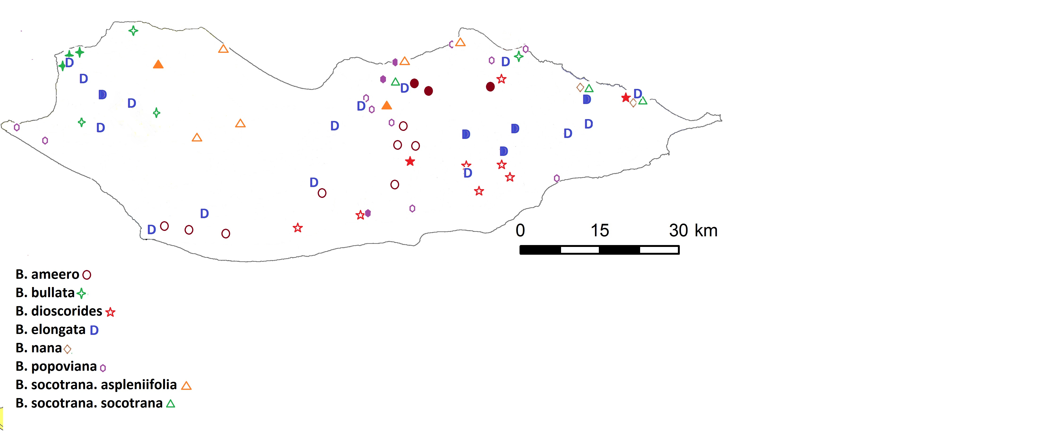

Figure 1. Map of known occurrence of all endemic Boswellia taxa on Socotra Island. Full symbols indicate source populations, empty symbols remnant populations with a few or even individual trees. Several areas, such as the central-western lowland areas are largely blank, lacking aimed botanical surveys.

Threatened Species/Habitat Type Targeted
Habitat type/species
Plant communities at low- and mid-elevation in Socotra Island are characterised by savannah woodlands and forests with frequent occurrence of Boswellia species. Currently this habitat is strongly affected by overgrazing and climate effects, the main causes of frankincense tree population decline on Socotra. The endemic species are restricted to very small populations (Boswellia ameero, B. elongata, B. socotrana sensu lato), while others are present on hardly accessible rocky slopes and their distribution and population sizes are not well known (B. nana, B. bullata, B. dioscorides, B. popoviana).

National laws
The habitat types on Socotra in which Boswellia species occur, fall under national protection of the Socotra Conservation Zoning Plan, Presidential Decree no. 275, ratified in 2000. This important Yemeni national law aims at 1) the protection of the unique biodiversity of Socotra, 2) to provide good management practices, ensure sustainable natural resource use without negatively impacting the environment and 3) to protect the genetic material of endemic species on Socotra (Art. 3, SCZP 2000). The Boswellia species fall under the definition of endemic species with unique genetic material currently affected by unsustainable resource use, while local management capacity is very limited due to regional political instabilities and poverty, therefore urgent conservation support is needed. In addition, the majority of the Boswellia populations occurs in the Socotra National Park and Nature Sanctuaries (ca. 70% of the island’s surface), which all have a high protection status in the zoning plan (SCZP, 2000); the same area has been designated as UNESCO Terrestrial Core Area since 2008. These habitats are increasingly threatened, terrestrial impacts affecting also other endemic and rare tree species, yet no formal (e.g., Red List for Ecosystems) assessment has been carried out so far. Locally, only in one Nature Sanctuary (Homhil), a management plan (2005) includes conservation of Boswellia elongata as one of the conservation priorities - local capacity has been low to implement any activities, and depends on external donor funding for realisation. Additional national laws relevant to the protection of endemic plants on Socotra include law no. 26 of 1995 on Environment Protection (and its by-law no. 148, 2000) and Decree no. 104 Concerning the Approval of the Regulations Protecting Endangered Flora and Fauna and Regulating their Trade. Yemen also ratified the Convention on Biological Diversity, which includes a commitment to the conservation and protection of endemic, rare and endangered species in the National Biodiversity Strategy and Action Plan of 2017 (implementing CBD 2011-2020).

IUCN Red List status
For the Boswellia species, all are threatened. IUCN Red List assessments date back to 2004 and are currently under revision due to an urgent need for updates; the certified expert assessing the Socotra plant species is involved in this project (Dr A. Forrest, RBGE/CMEP). The following IUCN Red List categories have been assigned to the endemic Boswellia, and the new assessments (to be published in 2019-2020) are included here, indicating urgent conservation measures are needed. The current project also aims at further updating this information and adding to our knowledge of the distribution and relevant threats, which will feed back into future assessments.

- Boswellia ameero VU B2ab(ii,iii) with new draft assessment Endangered B1ab(ii,iii,v)+2ab(ii,iii,v) due to increased knowledge about distribution and threats.
- Boswellia bullata VU D2 with new draft assessment as Near Threatened due to changes in IUCN Criteria.
- Boswellia elongata VU B2ab(ii,iii) with new draft assessment Endangered B1ab(ii,iii,v)+ 2ab(ii,iii,v) due to increased knowledge about distribution and threats.
- Boswellia dioscorides VU D2 with new draft assessment as Near Threatened due to changes in IUCN Criteria.
- Boswellia nana VU D2 with new draft assessment Endangered B1ab(iii,v)+2ab(iii,v) due to increased knowledge about distribution and threats.
- Boswellia socotrana, previously treated as a single taxon but according to new scientific data, about to be split into two sub-species. The species sensu lato was previously assessed as VU D2 but draft assessments for the species and two sub-species Boswellia socotrana subsp. socotrana and Boswellia socotrana subsp. asplenifolia are Endangered.
- Boswellia popoviana VU D2 with new draft assessment as Near Threatened due to changes in IUCN Criteria.

Current status of project
Previous conservation projects on Socotra have included Boswellia elongata and Dracaena cinnabari as tree flagship species, as part of larger activities, mainly focused on habitats in Nature Sanctuaries (which however cover only 2.5% of total land area in the Archipelago). No project focusing specifically on tree, woodland or forest conservation has been realised on Socotra Island yet. Nevertheless, conservation of forests and general terrestrial biodiversity have been included in previous and in ongoing projects.

Previous international projects
Several large conservation projects on Socotra started since 1997 and included conservation efforts in terrestrial ecosystems, such as the UNDP/GEF Conservation and Sustainable Use of Biodiversity of the Socotra Archipelago Project (1997-2002), the Socotra Conservation and Development Programme (SCDP; funded by UNDP/The Netherlands/Italy; Phase I 2001-2003; Phase II 2004-2008), the Socotra Governance and Biodiversity Project (UNDP; 2008-2016), several small GEF-grant programmes and the UNE/GEF Socotra Conservation and Sustainable Development Project (2016-2020). During the UNDP/SCDP programme, with support from the Directorate General for Development Cooperation (DGCS) in Italy, the Socotra Conservation Zoning Plan was realised in 2000, which defined the current zoning in the Archipelago, including the National Park, six small terrestrial Nature Sanctuaries, and aimed protection measures. However, since 2000, threats to the environment increased rapidly while conservation capacity could hardly follow; only one Nature Sanctuary (Homhil; Fig. 2) has a management plan; this plan contains protection measures for Dracaena and Boswellia, however it has only sporadically been implemented due to the limited capacity of the local government which suffers under a severe financial crisis due to the political instabilities on the mainland. The ongoing UNE/GEF project, which runs until Feb 2020 yet with the potential for extension, aims to improve sustainable resource management, combat exotic species, expand protected area network/management and increase capacity building. Therefore, the Boswellia project proposed here would be benefiting from the activities in this ongoing initiative and vice versa; the projects would complement each other (the UNE/GEF project aimed at more general conservation approaches, the Boswellia project aimed at more taxon- and habitat-specific grassroots activities), allow awareness, data streamlining and compilation of relevant data to the local conservation agencies, and increase the chances for sustainability of conservation efforts. No specific Species Conservation Action Plans exist for any of the tree species on Socotra and direct conservation measures for endangered trees, with aimed training, are urgently needed.

Previous Czech restoration projects
Predominantly, all efforts in forest conservation on Socotra in the past, have been carried out by Mendel University. Experts from this institute, which would be leading the Boswellia project, have been working on the island for more than 20 years mainly through development cooperation projects supported by the Czech Development Agency (CZDA). In the first phase (1998-2001), elementary information about the natural conditions of Socotra and their influence by humans, especially grazing by livestock, was obtained and evaluated. The first preliminary version of the geobiocoenological classification system was prepared, which units are important spatial frameworks for planning conservation and agroforestry measures. Subsequently (2002-2004), a map of altitudinal vegetation zones and biotope types classification was produced using remote sensing data. Based on the results of the first stage, agroforestry activities started, and research on tree populations, especially of the iconic dragon blood trees (Dracaena cinnabari), continued. Subsequently, during two other projects supported by Czech Development Agencies and the EU (2006-2012), the agroforestry component of the previous project was developed. Plants were grown as food for island inhabitants, as well as fodder for livestock, and real restoration efforts of local (principally endemic) trees began. The most appropriate starting point of sustainable use of the environment was to support the establishment of agroforestry activities through home-gardens using non-invasive plants producing edible vegetables and fruits and combining these efforts with planting endemic trees with local uses, providing immediate benefits to local residents. A larger intervention was the development project from the Czech Development Agency (2012-2014) aimed at increasing food security, nutritional food quality, and support of small-scale farmers by establishing new, or extending existing, home-gardens. Support was given to nurseries producing seedlings of agricultural crops and endemic trees; several agroforestry gardens and about twenty school gardens were established as model systems and as an example of good practice. Both agricultural crops and trees were planted here, especially endemic local trees, which provide shadow to young seedlings over time, and the entire set-up is protected from grazing by goats by local fencing and constant local community involvement. During this period, several local Socotran received training at MENDELU, leading to successful capacity building through active MSc and PhD students involved in local conservation. Since 2016, MENDELU has been a partner of the abovementioned ongoing UNE/GEF project implemented by Senckenberg Institute and EPA, which focuses on capacity building, sustainable land management, exotic species, revision of the zoning plan and streamlining biodiversity data to improve protected area management. The latter project has identified three pilot areas in Socotra National Park to demonstrate the impact of sustainable land use on biodiversity conservation through regeneration activities, however not primarily aimed at Boswellia and only in limited areas. The first outputs of the latter work show that the endemic trees on Socotra, like the iconic Dragon Blood Tree, suffer from the same threats as listed here for Boswellia, and that populations are declining (Maděra et al. 2019).

Franklinia project partners
The institutes partnering with Mendel University in the current Franklinia project (EPA Socotra, La Sapienza Rome, Royal Botanic Garden Edinburgh/Centre for Middle Eastern Plants and Senckenberg Research Institute) have been involved in nature conservation on Socotra since two decades, therefore there is a strong synergy and experience as well as a joint in-depth knowledge on the current needs and feasibility of conservation activities on the ground complementing ongoing efforts.
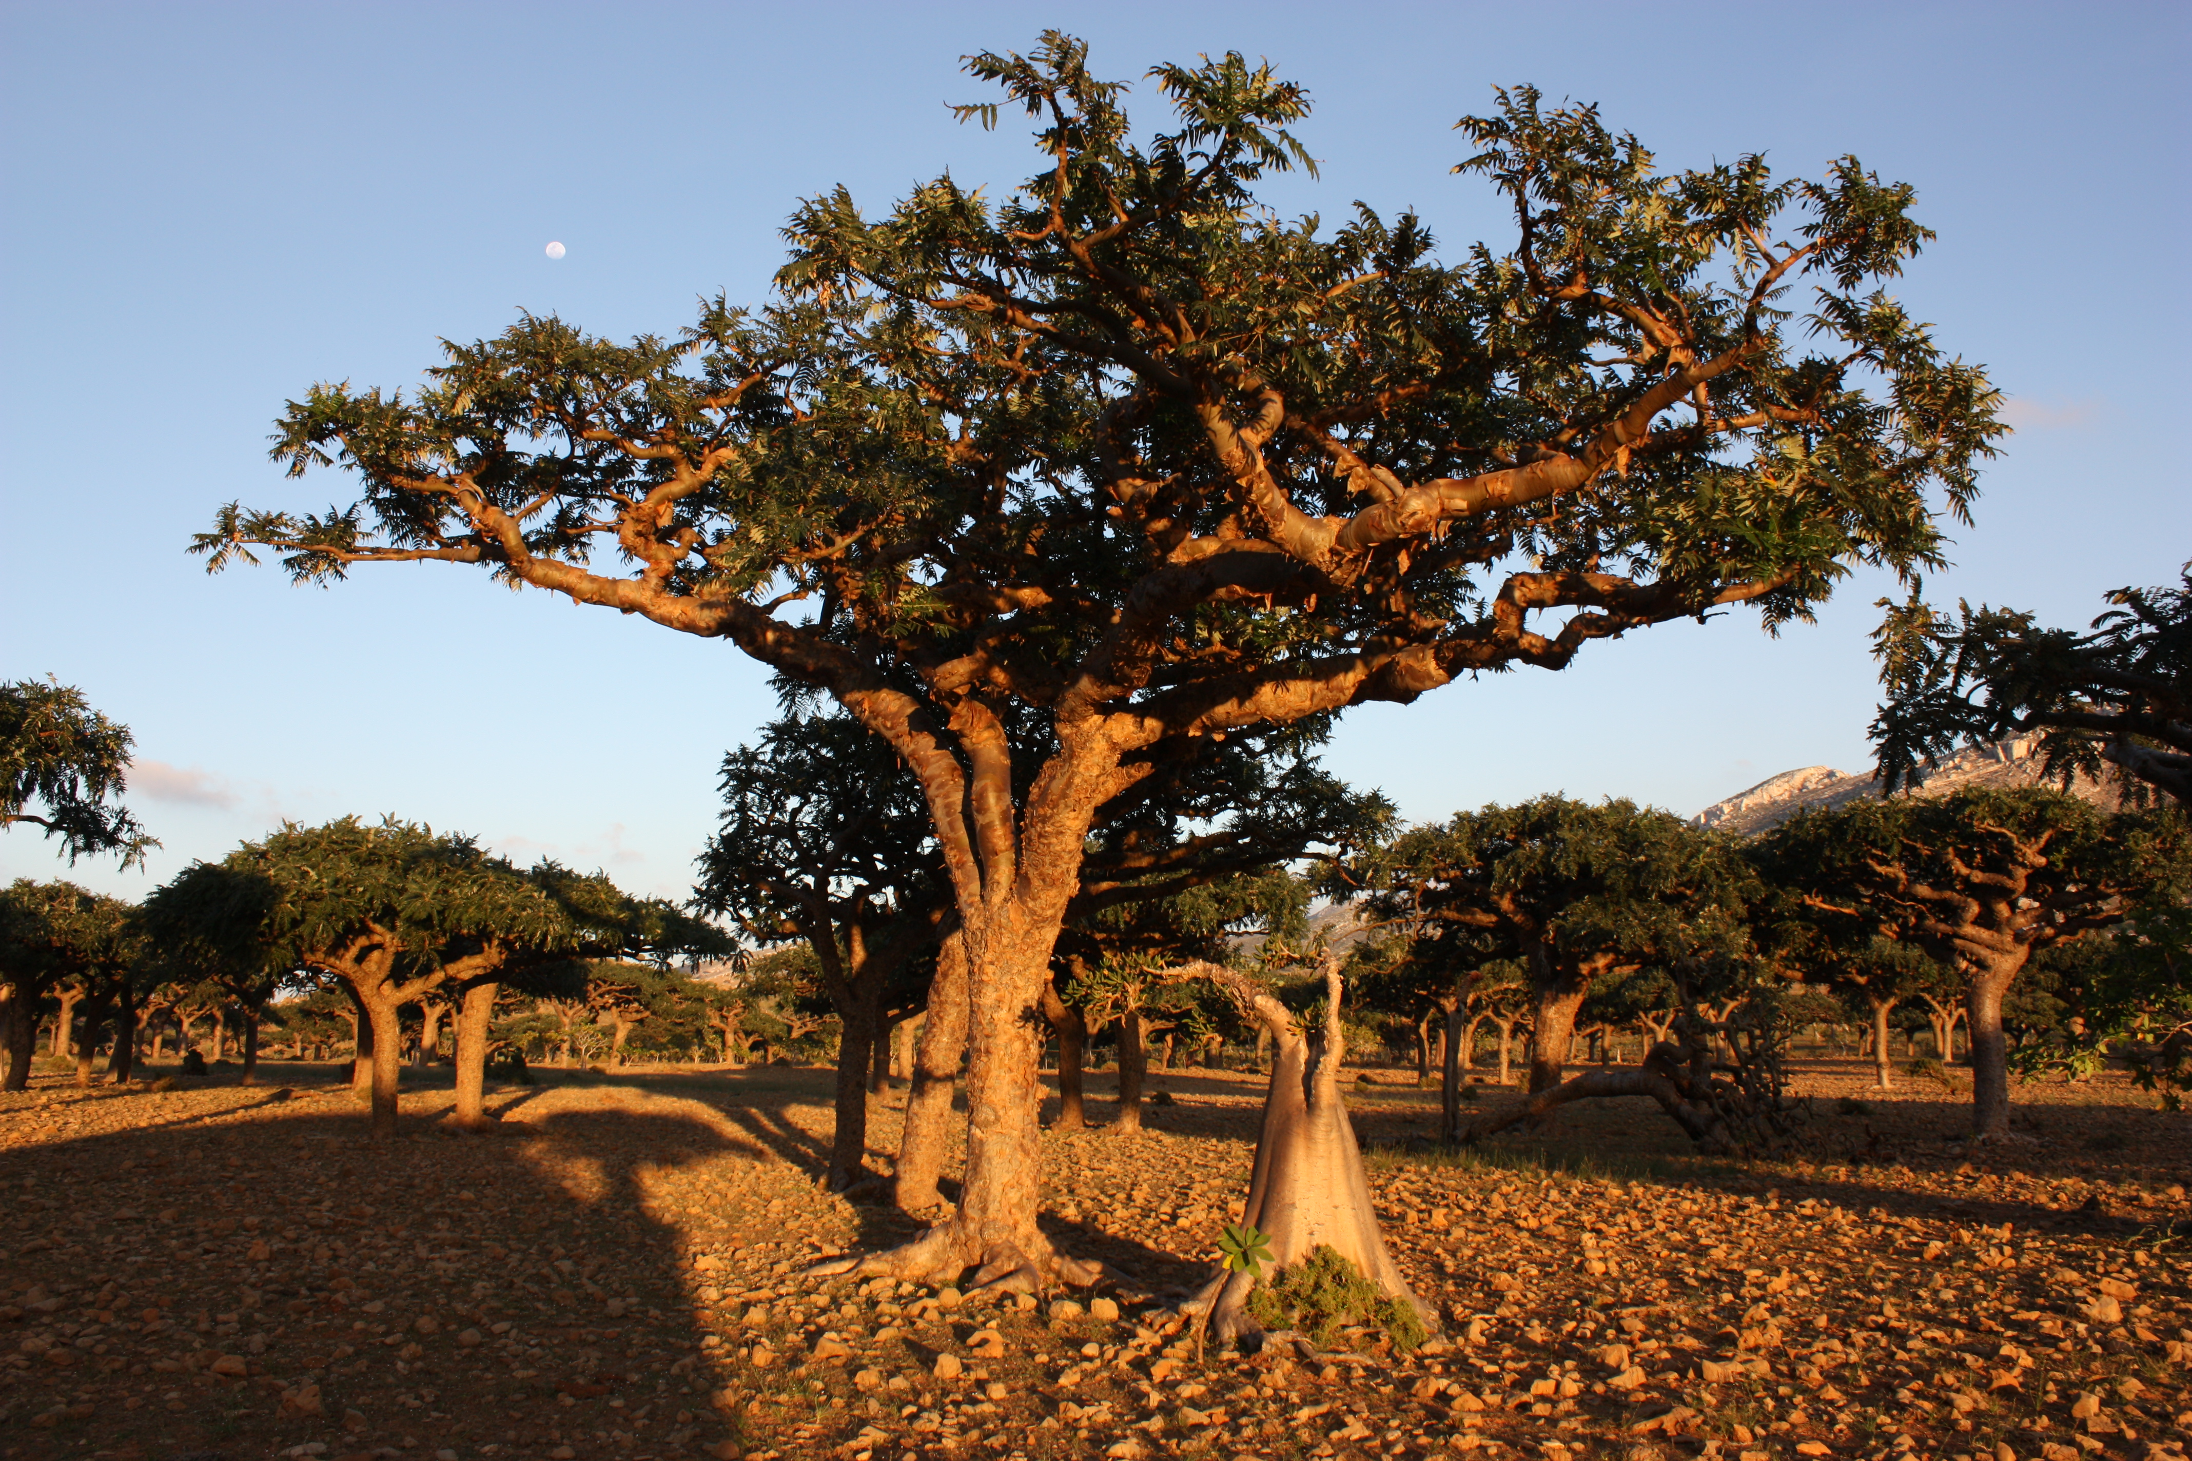
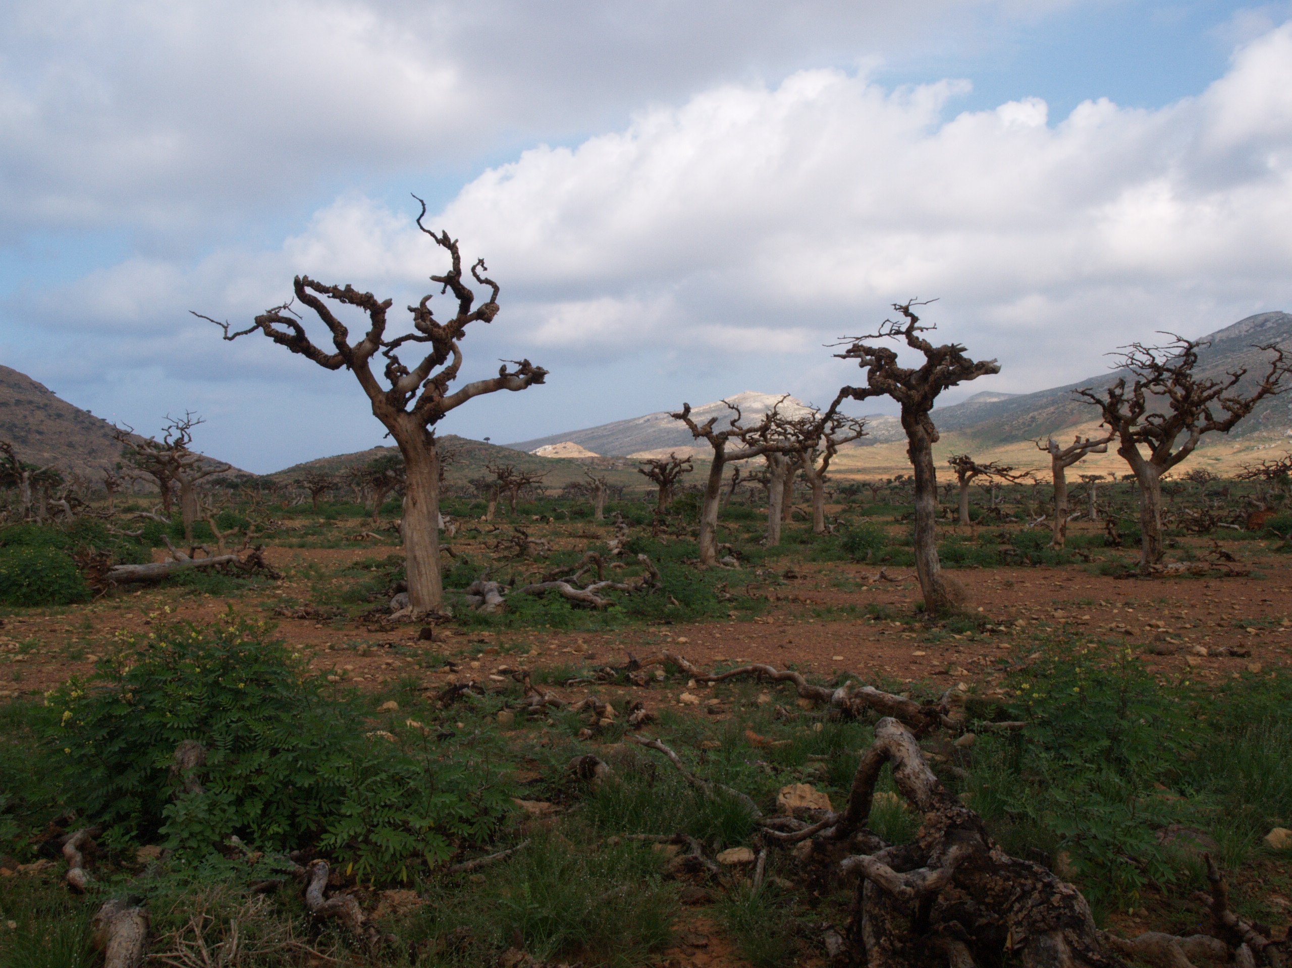
Figure 2. Boswellia elongata before (left) and after (right) the cyclones of 2015, Homhil Nature Sanctuary, Socotra Island. The local population of this endemic species counted approximately 1,000 trees before the cyclones, reduced to only 300 trees two years later. Due to intensive grazing by goats, virtually no new tree seedlings in this area survive regeneration without intervention.

Project Budget (in preferred currency)
Funding request: 273,599,- EUR
Total budget: 407,904,- EUR
Confirmed matching funds (in-kind): 134.305,- EUR
Information on matching funds: matching funds are in-kind, in the form of salaries of international experts (team members) corresponding to their involvement and roles in the project.

Information on in kind contribution: The ongoing UNE/GEF Socotra conservation and sustainable development project runs officially until February 2020, yet there is the possibility of extension of at least one year. In case the complementing UNE/GEF project extension is positive, on-the-ground logistics in 2020 would be facilitated.

Key Project Staff
Prof. Dr Ing. Petr Maděra, 50yrs, main project coordinator, 25%
Dr Ing. Hana Habrová, PhD, 41yrs, home-garden expert, 20%
MSc Samuel Lvončík, 38 yrs, expert on Socotran Boswellia, taxonomy, population inventory, 25%
Dr Ing. Petr Němec, 37 yrs, forest nursery, reforestation, 20%
Dr Petr Vahalík, 37 yrs, remote sensing, GIS-expert, 10%
MSc Markéta Smrčková, 34yrs, project administration, monitoring & evaluation, 10%
Dr Alan Forrest, 51yrs, population inventory, restoration, conservation assessment, monitoring & evaluation, 10%
Prof. Dr Fabio Attore, 50yrs, seed germination trials, population inventory, remote sensing, 10%
Dr Michele De Sanctis, 47 yrs, seed germination trials, population inventory, remote sensing, 10%
Dr Kay Van Damme, 43yrs, project vice-coordinator, scientific advisor, nature conservation training and awareness, protected area management, capacity building, 10%

Project partners, collaborations, stakeholders and consultations directly involved in implementing and planning this project
Main Partners
Mendel University in Brno, Czech Republic – international organisation – main project coordinator involved mainly in tree re-plantation activities, home-gardens, inventory
Royal Botanic Garden Edinburgh, UK. Scottish Government Non-Departmental Public Body and registered charity – international organisation – project partner involved in support through technical, regional and botanical expertise to include conservation assessment.
Sapienza University and Botanic Garden in Rome, Italy – international organisation – project partner involved in inventory and germination trials.
Senckenberg Society for Nature Research, Frankfurt am Main, Germany – international organisation – project partner involved in biodiversity conservation, conservation training, awareness and protected area management.
Environmental Protection Authority Socotra (EPA), Hadibo, Republic of Yemen – local government agency – advisory body.

Note: other local stakeholders (e.g., local NGOs) will be identified during the course of the project, where we can build on 20 years of conservation activities and ongoing collaborations on the ground of the involved institutes and agencies listed above.
We expect the local NGOs will be entirely initiated by Socotri, but we could suggest following NGOs based on our experiences within previous mutual cooperation: Skand Dragon Tree Association, Socotra Wildlife Association, Homhil Protected Area Association, Woman Association, local Elementary schools. Socotri stakeholders include – Local Governorate, Agriculture Office, Education Department.

Project rationale:
- Background and Justification:
Background
Frankincense trees, culturally and economically important trees which form a crucial part of human history (Maděra et al. 2017), are currently endangered around the world by overgrazing and olibanum harvesting. However, these plants are part of one of the most fragile ecosystems - savannah forests and woodlands in arid-tropical zones. Socotra Island hosts eight endemic taxa of the genus Boswellia which are facing the same threats affecting their habitats (Attore et al. 2011, Miller et al. 2004, Lvončík, Řepka 2019, Maděra et al. 2019). Socotra harbours the area with the highest concentration of frankincense species in the world (Thulin, 2001). The trade with olibanum and other kinds of resin developed in Socotra since ancient times and is still practiced at a small scale today (Cheung, DeVantier 2006; Naumkin, Epstein 1993).
Local inhabitants of the island have been shepherds for more than 2000 years (Miller et al. 2004) and in previous times, when the human population density on Socotra was lower, tree species had higher chances to regenerate naturally, leading to cohorts of century-old Dracaena trees today (see Maděra et al. 2019). After World War II, the human population started to grow on Socotra and changes in traditional land management intensified. The increase in the local human population, directly connected to the growth of livestock abundance, affected the island’s terrestrial environment. Moreover, during the last few decades, people living in rural areas moved to settle in towns and villages. Increased land value and resulting division of land between tribes has resulted in an increase in land ownership disputes. This has caused more pressure on some areas while reducing the movements of livestock as the Socotrans have become more sedentary. Together with the breakdown of traditional animal husbandry practices which affects the local terrestrial environment (Van Damme, Banfield 2011), an expanding network of (tarmac) roads has triggered an increased grazing pressure, increasing the number of available and accessible grazing areas throughout the year. While at the beginning of 1950s, the number of goats and sheep was estimated at 19 and 26 thousand respectively, recent estimates indicated about 220 thousand livestock individuals (Scholte et al. 2007) to now about 444 thousand goats and 77 thousand sheep in 2019, according to our demographic survey in the ongoing UNE/GEF project. Currently, free pasture is practiced on the island and it seems that the goat population is far over a sustainable limit. Scientific research has shown that unique lineages of trees on Socotra have directly suffered from unsustainable resource use, and additionally have been affected by climate change impacts (Socotra Dragon Blood Tree; Maděra et al. 2019).
Currently practiced land use of the local inhabitants is leading to overgrazing and a lack of regeneration, leading to population declines and local population extinctions of several tree species. The situation is worse for Boswellia because these trees seem to be surprisingly short living organisms (only up to 100 years, Hušková 2019). Moreover, cyclones have been occurring more often on the Island due to global climate change and are damaging or killing mature trees; having soft wood, frankincense trees are very sensitive to strong winds. The last devastating cyclone impacts, in November 2015 and May 2018, destroyed large proportions of the Boswellia populations in well-studied areas such as Homhil Nature Sanctuary, to great concern of the local communities and international conservation agencies alike.
Rationale / Justification
The Boswellia taxa on Socotra are in dire need of protection and improvement of conservation management, because: 1. They represent a genetically unique insular group of endemic trees and the largest radiation of frankincense trees on the planet (8 endemic taxa). 2. Terrestrial impacts on Socotra such as unsustainable resource use (overgrazing) and climate change impacts are real, lead to direct decline of tree populations and affect other endemic and/or rare tree species in the same habitat; conservation measures will help to protect not only Boswellia, but generally increase biodiversity. 3. Boswellia trees have local cultural and economical importance, and their decline has risen concern by local communities; the project therefore answers to, and will be supported by, a local need for conservation. 4. National and local government agencies benefit from this project through increasing their capacity and facilitate the implementation of conservation by providing support related to the protection of biodiversity and specifically of genetically unique (endemic) lineages, such as Boswellia. In addition, the project tackles directly major threats that have been identified as affecting the universal value of the Socotra Archipelago UNESCO Natural WH Site: unsustainable land use and increasing resilience of local biodiversity to climate change impacts. 5. The project will aim at awareness and local training specifically for Boswellia and focus on sustainability of its outputs through constant monitoring and evaluation. This is crucial to the long-term survival of these tree species, the majority of which, without conservation intervention, may go extinct through human-induced impacts (see Maděra et al. 2019 on Dracaena cinnabari).
Previous experience and complementing projects
Mendel University in Brno, within the framework of several conservation and development projects implemented on Socotra, has decades of experience with tree re-plantation and reforestation on Socotra and is one of the few international institutes with hands-on practical knowledge and close cooperations with local communities in this issue. We examined the outputs of different conservation and reforestation measures, from individual re-plantation to small-scale and large-scale reforestation. We refer to publications in the reference list at the end of this proposal by the Mendel University research group, and those by the other institutes partnering for this project.

Based on our previous experience, it emerged that:
1. Every re-planted tree must be protected for several years against browsing due to the high density of goats.
2. Involvement, awareness, training and ownership of local communities towards sustainable efforts is crucial. Without it, young seedlings do not get protected long enough from grazing.
3. Due to the very harsh climate (severe droughts alternated by strong rains during monsoon periods) iron fences corrode in a few years, thus for fencing it is necessary to use stones or strong galvanized materials.
4. Large-scale reforestations (1 hectare and more) are unfeasible due to land ownership and the need for livestock browsing which is affected by fencing open areas. Larger exclosures designed to reforestation work effectively only if shepherds use them for other productive agroforestry systems such as home gardens and honey production.
5. The most effective way is re-plantation with protection of individual trees by galvanized strong iron fences like in urban areas.
6.Home gardens are successful for tree plantation. This measure has a low cost-ratio per tree and has a high educational importance and in fact, there are many examples where species have been preserved only through cultivation and by protection from goats in home gardens.

The above considerations, based on years of experience with local stakeholders on Socotra, will be put into practice during the current project and can therefore be further refined and evaluated in particular related to Boswellia.
Within the framework of the ongoing UNE/GEF project Support to the Integrated Program for the Conservation and Sustainable Development of the Socotra Archipelago, Mendel University team is currently working to improve sustainable land management practices in Homhil National Park (Socotra), where the biggest population of Boswellia elongata occurs. This area was selected as a pilot area and reforestation activities focused on B. elongata forest which was largely destroyed by two subsequent cyclones in 2015. The UNE/GEF project focuses on four main fields – 1) Biodiversity/Protected Area Management, 2) Invasive Alien Species, 3) Sustainable Land Management and 4) Capacity Building.
The Franklinia project would complement in, and coordinate with, some of the activities in components 1 and 3 in the ongoing UNE/GEF project, where the collected information on Boswellia can feed into general improvement of protected area management and sustainable land management. The main difference between the projects is that the Franklinia project provides conservation measures for a particular group of trees and habitats on Socotra Island; the UNE/GEF project is much more general, across taxa in terrestrial and marine ecosystems, and focuses mainly on improving governance (such as the zoning plan revision); therefore aimed conservation of endangered tree species with important ecological and cultural values, is not targeted, and specifically aimed activities are direly needed and requested by local communities. The impacts and local concerns related to the most recent cyclone in 2018 during the lifetime of the UNE/GEF project, also emphasized the importance of more aimed tree conservation measures. Besides the UNE/GEF project, which ends in 2020 with the potential for extension, there are no other conservation projects on Socotra, while the capacity of EPA to implement protection measures is low due to limited government funding, therefore the current Franklinia project also would complement the latter project temporally, at least for an important terrestrial group of endemics. Furthermore, in the current project proposal, we focus on all Boswellia species, and on specific areas with more abundant occurrence (tens or hundreds individuals) for reforestation in order to improve the most important (source) populations and stimulate survival and resilience of the largest insular Boswellia diversity in the world.

- Summary of the conservation status of the target species
Conservation status
The Socotra Boswellia trees were selected because of their conservation status (in the new draft assessments), and the fact that this entire group of endemics represents the largest insular radiation of Boswellia anywhere in the world adapted to a special (mainly semi-arid, limestone) environment, a unique phenomenon for these trees. The conservation status for the Socotra Boswellia is (Miller 2004, A. Forrest unpubl. data):
- Boswellia ameero VU B2ab(ii,iii) with new draft assessment Endangered B1ab(ii,iii,v)+2ab(ii,iii,v) due to increased knowledge about distribution and threats
- Boswellia bullata VU D2 with new draft assessment as Near Threatened due to changes in IUCN Criteria
- Boswellia elongata VU B2ab(ii,iii) with new draft assessment Endangered B1ab(ii,iii,v)+ 2ab(ii,iii,v) due to increased knowledge about distribution and threats
- Boswellia dioscorides VU D2 with new draft assessment as Near Threatened due to changes in IUCN Criteria
- Boswellia nana VU D2 with new draft assessment Endangered B1ab(iii,v)+2ab(iii,v) due to increased knowledge about distribution and threats
- Boswellia socotrana, previously treated as a single taxon but according to new scientific data, about to be split into two sub-species. The species sensu lato was previously assessed as VU D2 but draft assessments for the species and two sub-species 6a Boswellia socotrana subsp. socotrana and 6b Boswellia socotrana subsp. asplenifolia are Endangered
- Boswellia popoviana VU D2 with new draft assessment as Near Threatened due to changes in IUCN Criteria

Socotra’s rich biodiversity benefits from Boswellia conservation
The conservation of Boswellia taxa will inevitably improve conservation outcomes of numerous rare, threatened, endemic and important species across Socotra which occupy similar habitats (semi-deciduous and savannah woodland). Socotra counts about 37% endemic species among its ca. 800 plant taxa, a large proportion occurring on the rich slopes and limestone plateaus, and this mid-level elevation vegetation benefits also here. Ground-dwelling Boswellia species occur in dry semi-deciduous woodland habitats that are extensive across Socotra and harbour a range of endemic species. For example, by focusing on regeneration of Boswellia, also cover is provided for other species in currently barren areas due to grazing. Cliff-dwelling species occur in habitats that often harbour many endemic and threatened plant taxa which is well known on Socotra (Miller & Morris, 2004). Investigation of these populations will also allow a full assessment of which additional threatened taxa are protected through the establishment of restoration areas, managed by local communities with the focus on key Boswellia species. In addition, replantation on slopes of valleys also protects entirely different ecosystems, such as freshwater ecosystems that currently are also affected by the loss of vegetation (and landslides) through overgrazing on Socotra. Other endemic and rare species, such as the Socotra reptiles (90% endemic) and birds (11 endemic species), as well as a large number of insects, directly benefit from vegetation restoration activities. No formal assessment of threatened ecosystems has yet been undertaken on Socotra, but all habitats occurring there are unique to the archipelago and are globally extremely rare.
Main threats
The main threats to Boswellia populations on Socotra are grazing, wood collection (including direct destruction), soil erosion and climate impacts. Overgrazing is related to the breakdown of traditional practices, which in itself can be seen as a threat to biodiversity on Socotra (Van Damme, Banfield 2011).
- In order to mitigate threats from grazing, the project will focus mainly on restoration activities (including fencing) and increase local technical capacities to help young trees grow under sheltered conditions until they can escape goat browsing; Boswellia grows fast, so a few years of care by the local owners, with support, can be very efficient.
- Threats from unsustainable resource use through wood collection and direct destruction (cutting of leaves as a fodder for livestock in the dry season, stem tapping for olibanum harvesting), will be targeted through awareness efforts in those areas most affected – this practice differs strongly between areas in Socotra and depends on cultural practices.
- Restoration also helps against soil erosion and landslides, which is a threat affecting rare cliff species, therefore the project will assess very specific conservation measures for the special cliff—dwelling Boswellia.
- Resilience of populations against climate impacts such as cyclones will be increased by investigating which areas were least affected by winds for replantation and improving agroforestry, which happens already in more sheltered conditions on the ground. For drought conditions, the project will aim at areas with potential for long-term regeneration.

As the above threats affect all tree species on the Island, the activities of this project would have a direct benefit for general tree conservation in Socotra.

- Social context:
Local community involvement
From experience on the ground, we know that the social context of tree conservation measures is very important on Socotra Island. The local inhabitants live in a tribal system in nearly all areas of the island, which is, especially in usage of natural resources, strongly independent of local government administration. The Socotrans have been shepherds for more than 2000 years; in previous times, when the population density on the Island was lower, they were used to trees and forests that regenerated naturally by themselves. Also, they managed their pastures (including forests) properly, as the preserved but forgotten old walling system and traditional rules of trees and forests usage prove. After World War II, the local human population growth started and slowly habits changed. Increased human population is directly connected to the growth of livestock abundance. Over the last few decades, there has been a trend for people to settle in towns and villages, therefore land value and resulting division of land between tribes has resulted in an increase in land ownership conflicts. This has caused more pressure on some areas, and less movement of livestock. The expanding network of (tarmac) roads has triggered a larger grazing pressure in larger available and more accessible areas. While at the beginning of 1950s, the number of goats and sheep was estimated at 19 and 26 thousand respectively, estimates indicated 220 thousand of livestock in 1999 and 444 thousand goats and 77 thousand sheep in 2019. Currently, free pasture is practiced on the Island and it seems, the goat population is far over sustainable limit being 1-2 animals per hectare. The broad socio-economic context presently on Socotra is highly affected as well by the difficult situation in the mainland; although Socotra is safe from conflict, the lack of central government and increased poverty on the mainland affect management capacity of the local environment. Due to the strong relationship of local inhabitants to their land, all and any conservation measures on Socotra are done in direct their agreement and cooperation with local communities, something we have a long experience in.
Therefore, in all activities in this project, from awareness to technical exchange of knowledge in restoration, re-plantation, establishing local nurseries and surveys, local communities will be actively involved and will participate, as this is the only way to stimulate sustainable conservation. On Socotra, we have decades of experience in working with local communities in conservation activities and we can therefore assess feasibility well. In the past, we established thus a Dracaena replantation plot, which is now independently, and with great care, being maintained by a local tribe on Socotra. As Boswellia also provides an economical service (frankincense) for the local communities, the importance of conservation of these trees is also easily explained and people are rapidly involved, especially since a growing local concern related to climate change impacts. The current project answers these concerns, coming in the first place from local communities who depend on their land for survival.

- Goals and objectives: (Explain the general goals of your proposal and present the concrete objectives of your activities. Write the objectives in concise words and ensure they are specific, measurable, achievable, results oriented and timed.)
The main goal of the project is the conservation of the endemic Boswellia species occurring on Socotra Island. Frankincense trees have not only natural value as umbrella species of savannah woodland and forests on the island, but also a significant cultural value through the long history of olibanum harvesting and trade. Specific objectives of the project will be:
- Baseline inventory of all Boswellia species in Socotra – there are large gaps in our knowledge about the occurrence of generally all plant species on Socotra (insufficient floristic survey, hard accessible areas) and almost no knowledge about the abundance of individual species. If any, they are out-of-date since the cyclones in November 2015 and May 2018. Proper inventory allows us to make accurate evaluation of the conservation status of Boswellia species and strategize conservation measures.
- Conservation measures increasing resilience – evaluation of seed germination which is generally very low in Boswellia, establishment of tree nurseries, re-plantation of trees in selected areas and in home-gardens (for example, the cultivation of Dracaena draco in the Canary Islands preserved this species which is now present, yet it went extinct in the wild)
- Community involvement, capacity building and awareness - Training of local communities and technical staff; training will be targeted at all levels of society to address the urgent need of tree conservation and regeneration; this will improve education and increase cooperation with local associations that benefit from these trees (for example local bee keeping association). Awareness efforts will also include emphasizing the local cultural value and uses of these trees and focusing on the benefits from Boswellia forests for a variety of economic activities.

- Description of the proposed activities and justification of their effectiveness and benefits:
Note: there is currently no Species Conservation Strategy or Action plan for any Boswellia species on Socotra.
Project outputs and activities
Output 1. Baseline Data Collection
Activity 1.1. Boswellia species Inventory and training of local expert team
Description - The Royal Botanic Garden Edinburgh, project partner in this proposal, is managing a comprehensive and up-to-date database of Socotra plant distribution compiled from various sources and collections, including all Boswellia species. Regarding Boswellia inventory, two publications were made (Attore et al. 2011 and Lvončík et al. 2013) about species distribution across Socotra. Both were carried out before the 2015 cyclones for which the first field observations indicate the situation has changed severely. Therefore, the areas with known occurrence of Boswellia species will be re-visited and the abundance of these populations will be re-estimated. Also, the “blank places” in Socotra´s plant database will be visited looking for new yet unknown populations. The local expert team will be trained for these purposes because the scope of field works exceeds the capacity of international experts. As a result of this activity, the re-assessment of Boswellia conservation status on Socotra Island will feed into the IUCN Red List. This activity will also include mapping and integrating field and remote sensing data to follow up on changes in local habitats where Boswellia is found.
Activity 1.2. Threat assessment
Description – During collection of field data on the distribution and abundance of Boswellia species in the wild, a systematic threat assessment of the main existing impacts will be included. The threats include cyclone impacts (and exposure/vulnerability to wind), soil erosion, wood collection/direct destruction for human (firewood), grazing, urbanisation/construction and other environmental impacts that may be observed during the lifetime of the project. Mapping of threats and understanding impacts related to various factors (e.g., vicinity to road) will be included in this activity, in which the lead and partnering institutes have the technical capacity
Activity 1.3. Environmental involvement of local communities
Description – Baseline data on community involvement and awareness will be collected (through questionnaires) in target areas for replantation at the onset of each activity, in order to feed into Activity 4.1 (see below) and form a baseline to monitor progress, change and environmental involvement of local communities in tree conservation activities.
Activity 1.4. Assessment of regeneration plots
Description – Baseline data will be collected systematically for each regeneration plot for growth (all) and plant biodiversity (not home-gardens) to assess diversity of non-Boswellia plant species and followed up during the lifetime of the project to record which other species benefit from the activity while reducing grazing intensity.
Output 2. Conservation measures
Activity 2.1. Establishment of forest nurseries
Description - Local small forest nurseries will be established in the areas of the “source” population, where we will plan the reforestation activity. For seedling production, we will use only seeds from local trees to avoid artificial contamination of genetic sources and disturb natural evolution processes. Forest nurseries will be placed close to the source of water, or irrigation will be provided. The seedling will be planted in plastic bags that enable transport and re-plantation without root system damage. For any reforestation activities the forest nurseries are a must; this activity will facilitate any reforestation interventions.
Activity 2.2. Seed germination
Description - Most Boswellia species have a very low germination rate. For the Socotran species, information about germination capacity is missing. Thus, seeds of different species from different populations will be collected, quality of seeds will be evaluated, seeds germination trials will be carried out in situ, and finally seedlings will be replanted in the same area. This activity will be linked to capacity building of technical knowledge for seed germination, that can be continued by local communities and conservationists after the lifetime of the project (Activity 3.2).
Activity 2.3. Agroforestry in home-gardens
Description - Local people on Socotra like, and often depend on, home-gardens which are becoming an important part of their settled life. Support of home-garden establishment by material (fence, irrigation system) enable also native tree planting beside the establishment of local vegetable or fruit trees. The native tree provides shadow for vegetables and profits from watering, growing in a sheltered environment and protected from goat browsing. Home-gardens will allow the local population to utilize a variety of plants being grown there. The local people prefer tree species with ethnobotanical use (a category to which Boswellia species belong), therefore linking to a cultural and economic value (resin).
Activity 2.4. Reforestation of selected populations
Description - The tree plantation with individual protection is the most acceptable and effective way of reforestation. We will choose the most important source populations of ground growing Boswellia species for this purpose and select the best areas for replantation, in cooperation with local communities. For protection we will use the strong galvanized iron fences which allow multiple use, which is an advantage for long-term sustainability. Within the UNE/GEF project we provided demographic survey that show the occurrence for more than four thousand bee hives around the Island. Therefore, local beekeeping associations can be potential stakeholders as they are strongly depending on the occurrence of flowering trees.
Output 3. Capacity Building and Awareness
Activity 3.1. Awareness and Education
Description - Presentations and brochures in Arabic on forests and woodlands importance and potential threats will be prepared, including instructions how to plant trees. The trainings and workshops will be organized preferably in selected areas for reforestation, and aimed activities will be included for schools to stimulate maintaining local ethnobotanical knowledge in Boswellia. Potential socio-economic benefits of Boswellia as a source of resin and the potential of conservation activities to ecotourism will be communicated as part of this activity.
Activity 3.2. Local stakeholder training
Description – Local people including both local communities as well as EPA staff and other stakeholders in Boswellia conservation, will be involved in all steps of the project and provided training. In particular in threats assessment, mapping, seed germination, maintaining nurseries, replantation activities and follow-up, capacity building will be crucial for sustainability of the activities after the project’s lifetime.
Output 4. Improving Project Sustainability
Activity 4.1. Monitoring and Evaluation
Description – Identification and follow-up of indicators and monitoring effects during the project to assess real improvements in Boswellia tree conservation have been achieved. This allows adaptive monitoring in order to assess and deal with new issues to ensure success of the outcomes and a degree of flexibility. This sustainability plan will involve local communities and EPA.
Activity 4.2. Socio-economic benefits
Description - Potential socio-economic benefits of Boswellia as a source of resin and ethnobotanical uses, the potential of revenue through ecotourism (e.g., visitors to see conservation activities and resin products as a revenue) and other mechanisms will be explored here to assess long-term sustainability of the activities. Also the impact of regeneration activities and fencing on the occurrence of other species in the habitats and the benefits for local communities will be monitored.

- Outcomes:
Time frame and outcomes/milestones (in trimesters)
Year 1 (2020)
Main Outcomes: First field surveys and threats assessments conducted, inventory started, areas for reforestation selected, first nurseries established, seeds collected, seed germination trials established, training program and first awareness materials (English/Arabic) prepared
Milestones Year 1
  - Local expert inventory team established and trained, inventory started
  - Access to seedlings
  - Conservation measures strategy developed together with local stakeholders
Year 2 (2021)
Main Outcomes: Reforestation activities started, fences imported, home-gardens selected and supported, inventory and seed germination trials continued, local trainings and workshops organised
Milestones Year 2
  - Field surveys finished
21.2. Beginning of regeneration of the species
21.3. Cultivation of species to conserve from extinction
21.4. Promotion of the Boswellia conservation strategy through the communities
21.5. General capacity building and awareness
Year 3 (2022)
Main Outcomes: Trees replanted and monitored, baseline data analysed and shared, final evaluation of inventory and seed germination trials
Milestones Year 3
  - Knowledge on distribution and abundance of Boswellia species population gained and their conservation status re-evaluated
  - Boswellia conservation measures fully implemented
  - Local stakeholders apply conservation measures
  - Awareness/Capacity building activities completed
  - Joint publications

- Assumptions, risk assessment and uncertainty management:
For a detailed explanation of each activity and leading to expected outcomes, see under point 10 above. Risk assessment presented below. The current institutes are continuously, with several field visits yearly) involved in on-the-ground activities on Socotra, therefore the local situation can be assessed with the best knowledge and experience. Despite instability in the mainland, Socotra, and travel thereto, is safe, and conservation activities remain a priority for the local government agencies, both because of international involvement, as Socotra is a UNESCO World Heritage Site, and local involvement, as the local communities strongly depend on the environment for livelihoods and food security, and express strong concern related to land change and climate impacts.
Assumptions and mitigation measures
Assumption 1: the political and conflict situation in Yemen will not allow secure transport to Socotra for project actors
Mitigation 1: this can be ameliorated by bringing Socotran experts to remote locations for trainings; alternative routes exist as well, as actors can use the boat from Salalah seaport in Oman to reach Socotra safely
Assumption 2: local communities will not engage with the project outcomes, will not support the local activities, and will not see the benefits of long-term conservation
Mitigation 2: local community involvement is stimulated by previous work in several areas by many of the project partners, including influence of EPA and Governorate
Assumption 3: materials required for project work can´t be supplied or imported
Mitigation 3: materials not available on Island can be acquired in Oman or UAE and transported by boat to Socotra
Assumption 4: availability of water in tree nurseries
Mitigation 4: if there is no water source close to the nursery, the nursery will be equipped with a water tank and/or irrigation system
Assumption 5: what can be achieved in three years and what monitoring is in place beyond the life of the project
Mitigation 5: set up long-term monitoring and build the monitoring into EPA and community workplans beyond project timescale, and set agreed conservation status targets for improvement
Assumption 6: reduction of threat of over-grazing, especially in re-planted populations, and the social and economic implications for local communities
Mitigation 6: either by fencing until seedling escape browsing zone, rotational pasture system including exclosure areas from pasture
Assumption 7: Lifespan of fence will be shorter than time needed to replanting trees escape browsing zone
Mitigation: use of galvanized strong iron material, the cost per tree is high but the risk the seedlings will be browsed is minimalized
Assumption 8: cyclones will not destroy the new plantations or destroy existing populations further
Mitigation 8: cannot predict, but can monitor and can target restoration areas less affected by extreme weather

- Indicators:
- Number of inventoried populations, number of inventoried trees, number of inventoried floristic squares compared to existing knowledge, size of area surveyed
- Number of populations where threats have been assessed – detailed threat assessment and adaptive management to mitigate threats at a certain number of localities
- Number of maps including distribution of Boswellia and threats assessed
- Number of forests nurseries, number of produced seedlings, survival rates
- Number of re-planting trees, number of home-gardens with planting trees, survival rates
- Number of trainings and number of participants in trainings –activity 1.1. (outcome 20.1.), activity 3.1. and 3.2. (outcomes 20.3. and 21.4.)
- Number of non-Boswellia plant species in reforested plots vs. grazed adjacent plot, and monitoring of improvements in those species and in species diversity)
- Number of local communities and individuals according to the monitoring successfully involved in Boswellia conservation
- Number of presentations, publications and media outputs based on project results

- Long term sustainability and replicability:
See comments above about monitoring and evaluation, adaptive project management, sustainability plan involving local communities and Socotra Governorate and EPA (key partner). The long term outcome is that through training and awareness, local communities who benefit economically from these trees, will be perpetuating activities independently, followed up by newly established NGOs for the protection of Boswellia.
In addition, monitoring plots are established and training given to local management authority EPA with regular monitoring included in their forward work plan, also to engage communities some form of benefit (value chain etc) must be included as sustainable financing mechanism, or non-financial benefits from resource use (fuel etc) demonstrated to ensure people manage their trees sustainably.
The materials needed this project are aimed at long-term use, such as galvanized iron strong fences, which after growth of the tree to a reasonable size to escape browsing from goats, can be reused by local people for new replantation efforts or home-gardens.
Cultivation of Boswellia trees in home gardens has long-term effects, as these are directly connected to stimulating care of the trees, strongly linked to local livelihoods. Therefore, all efforts in this project to establish or stimulate local home-gardens that include Boswellia, ensure long-term sustainability as local people strongly depend on these home-gardens outside of the capital.
A potential value chain with non-timber forest products such as olibanum or honey, will ensure local benefits and create revenue from Boswellia regeneration. Although currently ecotourism is extremely low on Socotra, it is still present. Our activities will aim at stimulating “conservation tourism” where visitors learn about local efforts in tree replantation, linked to sales of tree products like olibanum. This system has worked successfully in a Dracaena regeneration plot on Socotra established by Mendel University with local communities, now one of the most popular ecotourism sites in the island, overlooking young Dracaena.

- Communication:
- Internal Communication
  - International Team
For communication among the international team members we will use regular Skype meetings, e-mail communication or mobile phone communication. Also a personal meeting once per year will be provided during the annual meetings of the Friend of Socotra towards the end of the year. A calendar with milestones for the project will be shared between partners and a website with basic designed to allow for transparency and communication.
  - Local Partners
For communication with local partners we will use mainly whatsapp, phone calls and emails. Internet connection on Socotra Island is extremely weak and does not allow Skype meetings. During field visits, international partners are expected to interact with local stakeholders, share information, have meetings and give presentations on their activities.
- External Communication
  - Publications
The project will lead to publications in scientific journals, especially from inventory and seed germination trials. For this we include open access fees in the budget. Re-assessment of IUCN criteria and a paper describing the process will be included.
  - Website
Information on all important project activities will be published on a website www.tropicalforestry.cz which is a platform for variety activities of university staff in academic, development as well as research activities. Update at least 2x a year.
  - Meetings/Conferences
Annual sharing of project development and research at an annual meeting of Friends of Socotra Society and other conferences that are yet to be identified. Local workshops will be organised on Socotra sharing information.
  - Other
Social media and promoting outreach to general public through popular media will be actively stimulated, including events and activities during world environmental days in which the project will actively participate (e.g., international day of forests).

- Legal aspects:
All laws outlined in the Socotra Zoning Plan and other national and international laws applicable to the current activities as stated above, are adhered to; for example, under this project, no seeds or plants would be transported out of Socotra. In fact, the current proposal supports the local government and EPA in their legal commitments and reporting to follow up on specific conservation measures and management of endemic tree species during times when a national financial crisis limits capacities. There is no legislative restriction for setting up local conservation measures on Socotra, including seed collection to establish local nurseries; all agreements are primarily with local communities and local agencies. It is vital to this project to respect local tribal rules and local government input, and all measures should be carried out with their agreement and cooperation. At the onset of the project, the main authorisation needed, is now already provided (agreement with EPA Socotra; signed June 2019).

- References:
- Attorre, F.; Taleb, N.; De Sanctis, M.; Farcomeni, A.; Guillet, A.; Vitale, M. Developing conservation strategies for endemic tree species when faced with time and data constraints: Boswellia spp. on Socotra (Yemen). Biodiversity Conservation 2011, 20: 1483–1499.
- Bauerová, L. Project and establishment of forest nursery on Socotra Island – transfer of European forestry know-how. Master Thesis, Mendel University in Brno, 2019, 157 pp
- Brown, G.; Mies, B.A. Vegetation Ecology of Socotra, 1st ed.; Plant and Vegetation 7. Springers: Dordrecht, Heidelberg, New York, London, 2012; pp 379.
- Ceccolini, L. The homegardens of Socotra island, Yemen: an example of agroforestry approach to multiple land-use in an isolated location. Agroforestry Systems 2002, 56, 107–115.
- Cheung, C.; De Vantier, L. (Eds.). Socotra - A Natural History of the Islands and their People. Odyssey Books and Guides, Airphoto International Ltd., Hong Kong, 2006.
- De Sanctis, M.; Adeeb, A.; Farcomeni, A.; Patriarca, Ch.; Saed, A.; Attorre, F. Classification and distribution patterns of plant communities on Socotra Island, Yemen. Applied Vegetation Science 2013, 16, 148-165. https://doi.org/10.1111/j.1654-109X.2012.01212.x
- Habrová, H.; Buček, A. Overview of biotope types of Socotra island. Journal of Landscape Ecology 2013, 6 (3), 60-83. https://doi.org/10.2478/jlecol-2014-0004
- Habrová, H.; Pavliš, J. Dynamic response of woody vegetation on fencing protection in semi-arid areas; Case study: Pilot exclosure on the Firmihin Plateau, Socotra island. Saudi Journal of Biological Sciences 2017, 24 (2), 338-346. https://doi.org/10.1016/j.sjbs.2015.09.030
- Hamdiah, S. Population structure of Boswellia elongate at Homhil, Socotra Island. Master thesis, Mendel University in Brno, 2015.
- Hildebrandt, A.; Eltahir, E.A.B. Forest on the edge: Seasonal cloud forest in Oman creates its own ecological niche. Geophysical Research Letters 2006, 33, L11401.
- Hušková, K. Perspectives of Boswellia elongata Balf. f. population development in Homhil (Socotra) and possibilities of its conservation. Bachelor thesis, Mendel University in Brno, 2019.
- Král, K.; Pavliš, J. The first detailed land cover map of Socotra Island by Landsat /ETM+ data. International Journal of Remote Sensing 2006, 27 (15), 3239-3250. https://doi.org/10.1080/01431160600646557
- Kürschner, H.; Hein, P.; Kilian, N.; Hubaishan, M.A. Diversity and zonation of the forests and woodlands of the mountains of northern Socotra, Yemen. Englera 2006, 28, 11-55. https://doi.org/10.2307/20358182
- Lvončík, S.; Maděra, P.; Volařík, D.; Vrškový, B.; Habrová, H. First proposal of seed regions for frankincense trees (Boswellia spp.) on Socotra Island. Journal of Landscape Ecology 2013, 6 (3), 35-45. https://doi.org/10.2478/jlecol-2014-0002
- Lvončík, S.; Řepka, R. Boswellia socotrana: one or two taxa? Novon, a journal for botanical nomenclature 2019, submitted
- Maděra, P.; Paschová, Z.; Ansorgová, A.; Vrškový, B.; Lvončík, S.; Habrová, H. Volatile compounds in oleo-gum resin of Socotran species of Burseraceae. Acta Universitatis Agriculturae Et Silviculturae Mendelianae Brunensis 2017, 65 (1), 73-90. https://doi.org/10.11118/actaun201765010073
- Maděra, P. et al. Sustainable Land Use Management Needed to Conserve the Dragon’s Blood Tree of Socotra Island, a Vulnerable Endemic Umbrella Species. Sustainability 2019, 11(13), 3557; https://doi.org/10.3390/su11133557
- Miller, A.G.; Morris, M.; Diccon, A.; Atkinson, R. Ethnoflora of the Socotra Archipelago, 1st ed.; Royal Botanic Garden: Edinburgh, UK, 2004; pp 759.
- Naumkin, V.V.; Epstein V.A. Island of the Phoenix: an ethnographic study of the people of Socotra. Ithaca Press, 1993.
- Scholte, P.; Al-Okaishi, A.; Suleyman, A.S. When conservation precedes development: a case study of the opening up of the Socotra archipelago, Yemen. Oryx, 2011, 45, 401–410.
- Scholte, P.; Miller, A.; Shamsan A.R., Suleiman, A.S.; Taleb, N.; Millroy, T.; Attorre, F.; Porter, R.; Carugati, C.; Pella, F. Goats: part of the problem or the solution to biodiversity conservation on Socotra? Technical report, 2007; pp 11.
- Socotra Conservation Zoning Plan. Presidential Decree no. 275 of the year 2000. Integral text, maps and background information. EPC, UNDP-GEF Socotra Biodiversity Project YEM/96/G32, 2000, 17pp.
- Thulin, M. Two new species of frankincense trees (Boswellia, Burseraceae) from Socotra. Kew Bulletin 2001, 56, 983–988.
- UNEP. Project Document – Support to the Integrated Program for the Conservation and Sustainable Development of the Socotra Archipelago. Project #5347. UNEP 2015, 116 pp. https://www.thegef.org/project/support-integrated-program-conservation-and-sustainable-development-socotra-archipelago
- UNEP/WCMC. Socotra Archipelago, Yemen. UNESCO Fact Sheet. World Heritage Sites –Protected Areas and World Heritage. United Nations Environment Programme & World Conservation Monitoring Centre, 2008, 11 pp. www.unep-wcmc.org/sites/wh/pdf/Socotra%20revised.pdf.
- Van Damme, K.; Banfield, L. Past and present human impacts on the biodiversity of Socotra Island (Yemen): implications for future conservation. Zoology in the Middle East Supplementum 2011, 3, 31-88.
- Van Rensburg, J.J.; Hopper, K. Incense and imagery: mapping agricultural and water management systems on the island of Socotra, Yemen. Proceedings of the Seminar for Arabian Studies 2017, 47, 129–138.

